MINUTES

STATE OF NORTH CAROLINA BOARD OF COMMISSIONERS
COUNTY OF HENDERSON MONDAY, MAY17, 2021

The Henderson County Board of Commissioners met for a regularly scheduled meeting at 5:30 p.m. in the Commissioners' Meeting Room of the Historic Courthouse on Main Street, Hendersonville.

Those present were: Chairman William Lapsley, Vice-Chair Rebecca McCall, Commissioner Mike Edney, Commissioner Daniel Andreotta, Commissioner David Hill, County Manager Steve Wyatt, Assistant County Manager Amy Brantley, Attorney Russ Burrell, and Clerk to the Board Teresa Wilson.

Also present were: Finance Director Samantha Reynolds, Director of Business and Community Development John Mitchell, Engineer Marcus Jones, Registrar of Deeds Lee King, HR Director Karen Ensley, Board of Elections Director Karen Hebb, Sheriff Lowell Griffin, Emergency Management/Rescue Coordinator Jimmy Brissie, Budget Manager Megan Powell, DSS Director Jerrie McFalls, Code Enforcement Director Matt Champion, Budget Analyst Sonya Flynn, Project Engineer Natalie Berry, Assistant Engineer – Site Technician Debbie Johnston, PIO Kathy Finotti – videotaping, Deputy Mike Marsteller as security.

CALL TO ORDER/WELCOME
Chairman Lapsley called the meeting to order and welcomed all in attendance.

INVOCATION
The invocation was provided by County Manager Steve Wyatt.

PLEDGE OF ALLEGIANCE
The Pledge of Allegiance to the American Flag was led by Alyssa and Airely Hart of the Young Naturalist 4-H Club.

RESOLUTIONS AND RECOGNITIONS
2021.28 Proclamation Proclaiming May as Older Americans Month 2021
Daniel Carey, Council on Aging Director of Development, has requested the Board adopt a Proclamation proclaiming May as Older Americans Month 2021.
Commissioner Andreotta read the Proclamation aloud.

Proclamation Proclaiming May as Older Americans Month 2021

Whereas, Henderson County includes a growing number of older Americans who have built resilience and strength over their lives through successes and difficulties; and

Whereas, Henderson County benefits when people of all ages, abilities, and backgrounds are included and encouraged to share their successes and stories of resilience; and

Whereas, Henderson County recognizes the shared need to nurture ourselves, reinforce our strength, and continue to thrive in times of both joy and difficulty; and

Whereas, Henderson County can foster communities of strength by creating opportunities to share stories and learn from each other, engaging older adults through education, recreation, and service, and encouraging people of all ages to celebrate connections and resilience.

Now Therefore Be It Proclaimed, that the Henderson County Board of Commissioners, do hereby proclaim May 2021 to be Older Americans Month. We urge every resident to recognize older adults and the people who support them as essential contributors to the strength of our community.

Commissioner Andreotta made the motion that the Board adopt the Proclamation Proclaiming May as Older American’s Month 2021. All voted in favor and the motion carried.

INFORMAL PUBLIC COMMENTS
- Dennis Justice spoke about HB 631 “Sports Betting” in which he was opposed.

DISCUSSION/ADJUSTMENT OF AGENDA
Chairman Lapsley made the motion to approve Consent Agenda with the addition of Facility Use Policy Exemption – Special Needs Sports, and Discussion Agenda as presented. All voted in favor and the motion carried.

CONSENT AGENDA consisted of the following:
Minutes
Draft minutes were presented for board review and approval of the following meeting(s):
April 21, 2021 - Regularly Scheduled Meeting

Motion:
I move the Board approves the minutes of April 21, 2021.

Tax Collector’s Report
The April 22, 2021 report from the office of the Tax Collector is provided for the Board’s information.

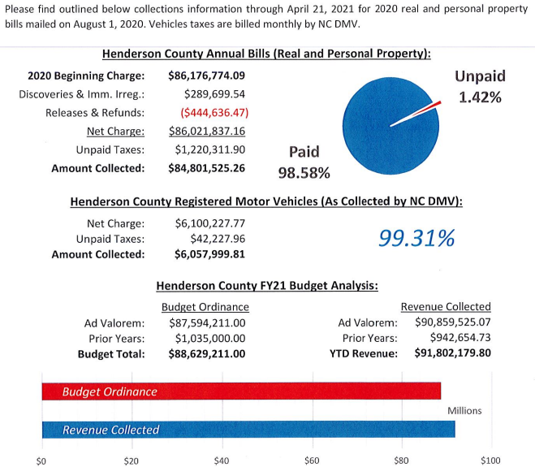

2021.29 Pending Releases and Refunds
The pending releases and refunds have been reviewed by the Assessor. As a result of that review, it is the opinion of the Assessor that these findings are in order. Supporting documentation is on file in the County Assessor’s Office.

These pending release and refund requests are submitted for the approval by the Henderson County Board of Commissioners.

Type Amount
Total Taxes Released from the Charge $ 784.65
Total Refunds as a Result of the Above Releases $ 5.17

Motion:
I move the Board approves the Combined Release/Refund Report as presented.

County Financial Report/Cash Balance Report – March 2021
The March 2021 County Financial and Cash Balance Reports were provided for the Board’s review and approval.
The following are explanations for departments/programs with higher budget to actual percentages for the month of March:

- Economic Development – payment of 3rd quarter Board appropriation and timing of payment of incentives
- Medical Services – Autopsies – timing and quantity of services provided
- Juvenile Justice – timing of provider appropriations
- Public Education – payment of 9th of 10 annual appropriations made to the public school system
- Interfund Transfers – transfer for HCPS MRTS

Motion:
I move the Board approves the March 2021 County Financial Report and Cash Balance Report as presented.

Henderson County Public Schools Financial Reports – March 2021
The Henderson County Public Schools March 2021 Local Current Expense Fund / Other Restricted Funds Report was provided for the Board’s information.

Motion:
I move that the Board approves the Henderson County Public Schools March 2021 Financial Reports as presented.

2021.30 Help American Vote Act (HAVA) Grant Funds
The Henderson County Board of Elections is requesting that the Board approve the North Carolina State Board of Elections HAVA Grant awarded to the department in the amount of $83,523.00. This grant will provide the equipment and supplies to improve and enhance the administration of elections.

Motion:
I move the Board of Commissioners approves the grant agreement and approve the Budget Amendment to receive the grant funds for the improvement and enhancement of elections administration.

2021.31 Budget Amendment – FEMA expenditures
The Board is requested to approve a Budget Amendment, transferring $311,829 from the General Fund (COVID response funds) to the COVID-19 Special Revenue Fund. This transfer represents the amount of COVID response expenditures which were eligible for FEMA reimbursement, and were incurred in FY2020. Due to the nature and timing of FEMA reimbursements, the Board is requested to fund these expenditures with the general fund appropriation for COVID response. Future FEMA reimbursements received will subsequently be recorded into the County’s General Fund.

Motion:
I move the Board approves the budget amendment as presented, transferring funds from General Fund to COVID-19 Fund.

Amendment 1 to the FY 2022 Consolidated Agreement NC Department of Health & Human Services (NC DHHS)
The Henderson County Department of Public Health is requesting approval of Amendment 1 to the FY 2022 Consolidated Agreement with the NC Department of Health & Human Services. The Board of Commissioners previously approved the master FY 2022 Consolidated Agreement on March 17, 2021. The email dated April 8, 2021 from NC DHHS staff outlines the fundamental changes represented in the amendment. The amendment should be signed by the same individuals that signed the original agreement, Mr. Bill Lapsley as County Official and Mrs. Samantha Reynolds as Finance Officer.

The Henderson County Board of Health reviewed and approved the document at their April 13, 2021 meeting with guidance to forward the agreement to the Board of Commissioners for their consideration and final approval.

The document has also been shared with the County Finance Director.

Motion:
I move the Board approves Amendment 1 to the FY 2022 Consolidated Agreement between the NC Department of Health & Human Services and the Henderson County Department of Public Health.

Juvenile Crime Prevention Council County Plan FY 2020-21
The Henderson County Juvenile Crime Prevention Council (JCPC) has approved funding for local juvenile crime prevention programs. These funds for Fiscal Year 2021-2022 in the amount of $266,020 are available for this purpose through the State of North Carolina. Each Program is required to provide a 30% match.
The programs approved by the J.C.P.C. are as follows:
- J.C. P.C. Administrative Expenses $5,400
- Blue Ridge Literacy Council $25,000
- Kids at Work $80,421
- Youth Mediation $30,000
- Hendersonville Boys & Girls Club $39,600
- Aspire Vocational Direction $55,599
- Trinity Place Temporary Shelter $30,000
Total $266,020
These Grant applications have been recommended for approval to the Board of Commissioners by Henderson County JCPC.
The Henderson County JCPC has approved the 2020-2021 County Plan for Henderson County. This County Plan has been recommended for approval to the Board of Commissioners by the JCPC.
Motion:
I move that the Board approves the JCPC recommendations for both the FY 2020-2021 Annual Plan, and the distribution of the FY 2020-2021 Juvenile Crime Prevention Program funds.

Facility Use Policy Exemption – Special Needs Sports – Add on
The County has received a request from Special Needs Sports to use the Historic Courthouse lawn the weekend of May 9, 2021, to sell tickets for a fund raiser.

To allow for this use on County grounds, the Board is requested to grant a one-time exemption to rule #4 of the County Facility Use Policy, which prohibits solicitation on the grounds. This exemption, if granted, would cover Saturday, May 9th and Sunday, May 10th.

Motion:
I move the Board grant an exemption to the County Facility Use Policy for Special Needs Sports, allowing for ticket sales on the Historic Courthouse lawn on Saturday, May 9th and Sunday, May 10th, 2021.

PUBLIC HEARING
2021.32 Close portion of Courtland Boulevard, Mountain Home Street, and Cosmos Drive Right of Way
Chairman Lapsley made the motion to go into public hearing. All voted in favor and the motion carried.

Autumn Radcliff stated Planning and Property Addressing staff have received petitions to close unopened portions of Courtland Boulevard, Mountain Home Street, and Cosmos Drive. Under North Carolina General Statute (NCGS) 153A-241, counties have the power to close any public road or easement not within a city, except public roads or easements for public roads under control of the Department of Transportation. To close any road, the Board must:

- Vote to adopt a resolution declaring its intent to close the public road or easement.

- Call and notice a public hearing on closing the road or easement, with notice “reasonably calculated to give full and fair disclosure of the proposed closing to be published once a week for three successive weeks before the hearing, a copy of the resolution to be sent by registered or certified mail to each owner as shown on the county tax records of property adjoining the public road or easement who did not join in the request to have the road or easement closed, and a notice of the closing and public hearing to be prominently posted in at least two places along the road or easement”.

- Hold the public hearing, where the Board must “hear all interested persons who appear with respect to whether the closing would be detrimental to the public interest or to any individual property rights”.

- Then, if the Board “is satisfied that closing the public road or easement is not contrary to the public interest and (in the case of a road) that no individual owning property in the vicinity of the road or in the subdivision in which it is located would thereby be deprived of reasonable means of ingress and egress to his property, the Board may adopt an order closing the road or easement.”

- File a copy of the Board’s order with the Register of Deeds.

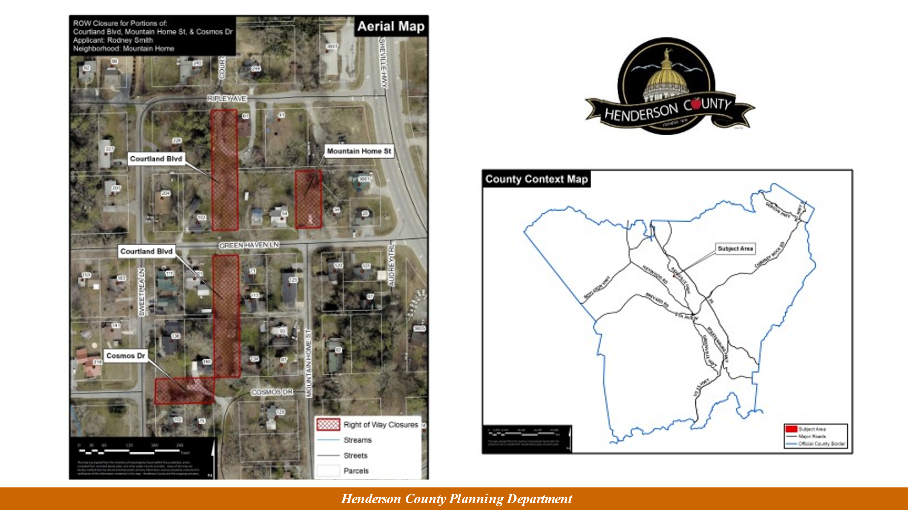
Public Input
There was none.

Chairman Lapsley made the motion to go out of public hearing. All voted in favor and the motion carried.

Commissioner Edney made the motion that the Board approves closure of the rights-of way and certify the Order of Closure. All voted in favor and the motion carried.

Discussion - New Business Items
COUNTY MANAGER’S FY2021-2022 Recommended Budget
The County Manager presented the FY 2021-2022 Recommended Budget during this meeting. He noted the Board met in January to discuss emerging issues and priorities.

The Board met in January and discussed emerging issues and priorities of the budget. The Tax Rate remains at $0.5610. in the proposed budget, and the County will be in position to maintain service levels at the same Tax Rate for two years with projection to remain the same for four years.

FY 2022 Base Budget
FY 2022 Projected Base Budget $166,709,933
Tax Rate .05610
Fund Balance Appropriated $ 15,815,018

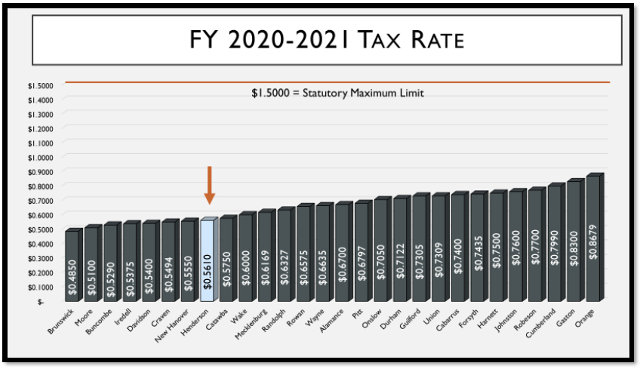

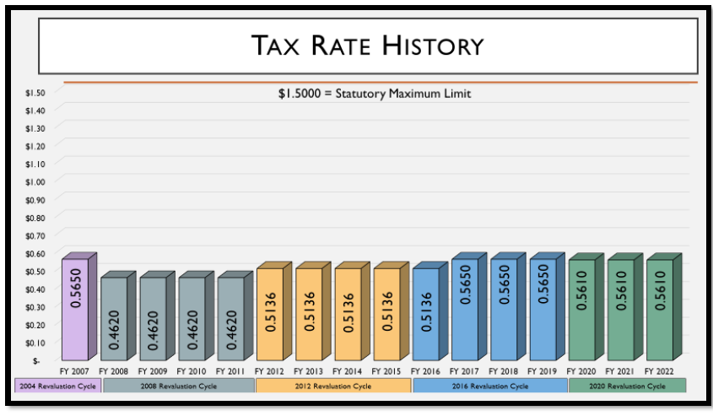

FY 2022 Base Budget
- Full funding of County’s Debt Service obligation of $20,381,954.
- Maintains funding to meet current and approved future obligations.

Proposed Expenditures
FY22 Proposed Expenditures - $166,709,933
FY21 Revised Budget - $161,525,732
$ Variance = $ 5,184,201
% Variance = 3.21%

FY 2022 Proposed Budget
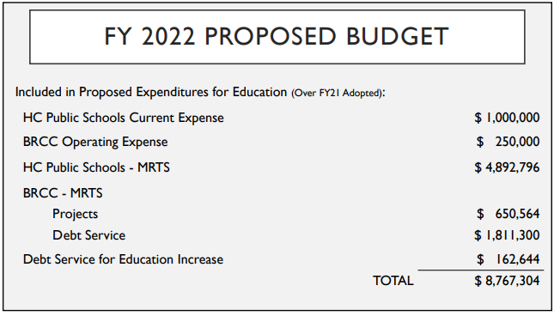

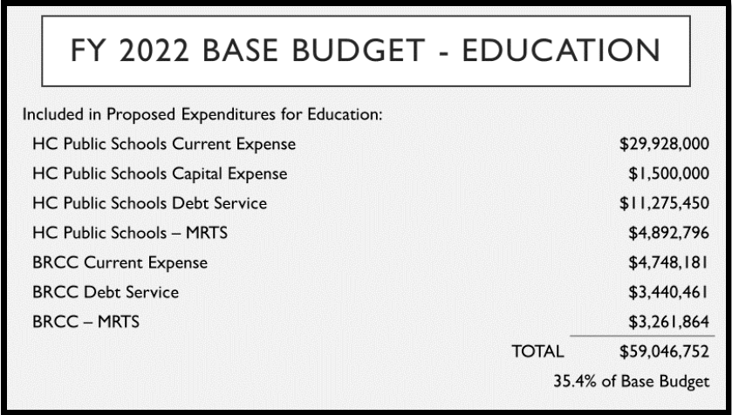

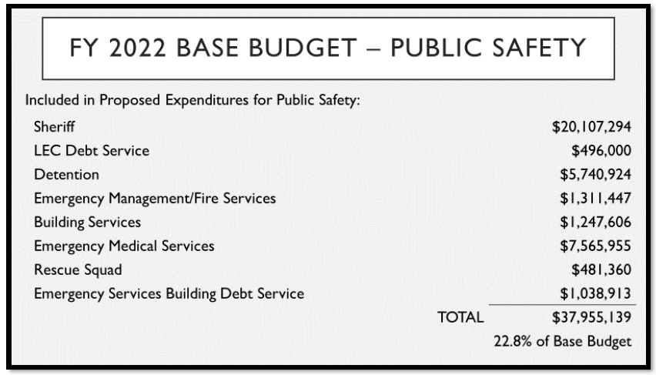

FY 2022 Base Budget
Education $59,046,752 35.4%
Public Safety + $37,955,139 22.8%
TOTAL $97,001,891 58.2%

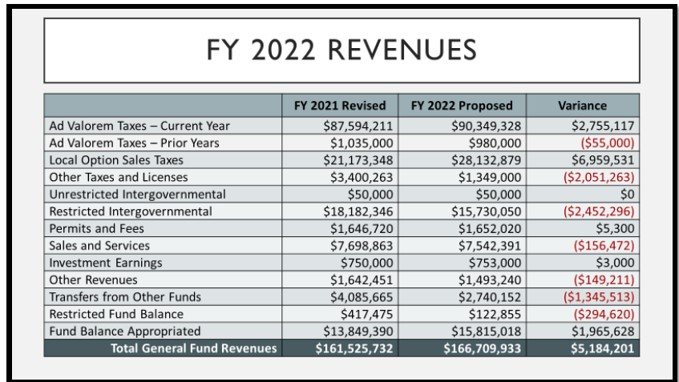

Proposed Expenditures $166,709,933
Proposed Revenues $150,894,915
Variance $ 15,815,018
Proposed Revenue / Proposed Expense Fund Balance Over 10% $ 16,369,340
Variance $ 15,815,018
TOTAL AVAILABLE FOR ALLOCATION $ 554,322

DEBT SERVICE SCHEDULE
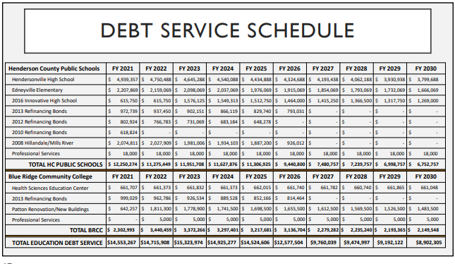
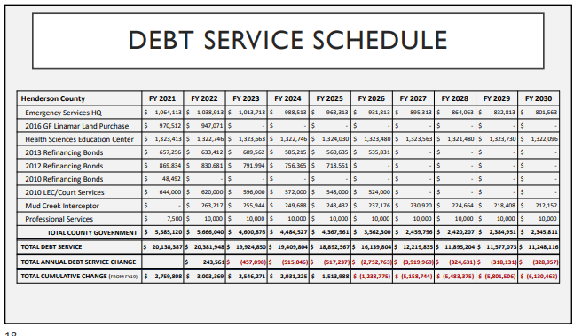

FY2022 Budget Process

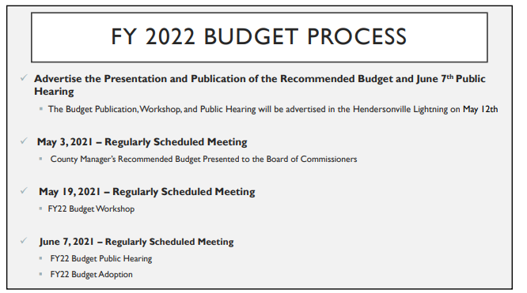

The Board is requested to schedule the Public Hearing on the FY 2021-2022 Budget for Monday, June 7, 2021 at 5:30pm.

Chairman Lapsley made the motion that the Board schedules the Public Hearing on the FY 2021-2022 Budget for Monday, June 7, 2021 at 5:30pm. All voted in favor and the motion carried.

ASHEVILLE REgIONAL AIRPORT UPDATE
Lew Bleiweis, Airport Director at the Asheville Regional Airport, will provide an update to the Board of Commissioners on the Asheville Regional Airport.



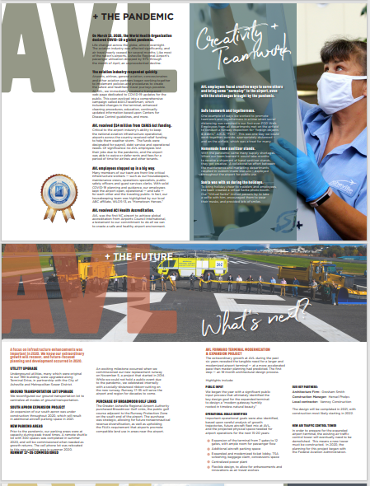

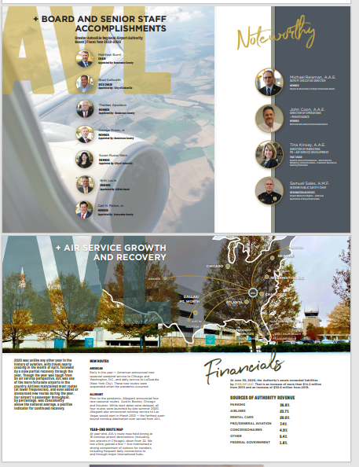

Commissioner Updates
Routine Updates from Commissioners
Commissioner updates include current and ongoing items of interest in the County and allow commissioners an opportunity to bring the full Board up to date on issues that occur between meetings. Commissioners may also use this opportunity to report on related committee work and assignments.

Topics for this meeting are as follows:

Water Safety Training Opportunities
Vice-Chair McCall had requested that Lori Kay Paden, Executive Director with the YMCA, provide the Board with an update on water safety training opportunities.

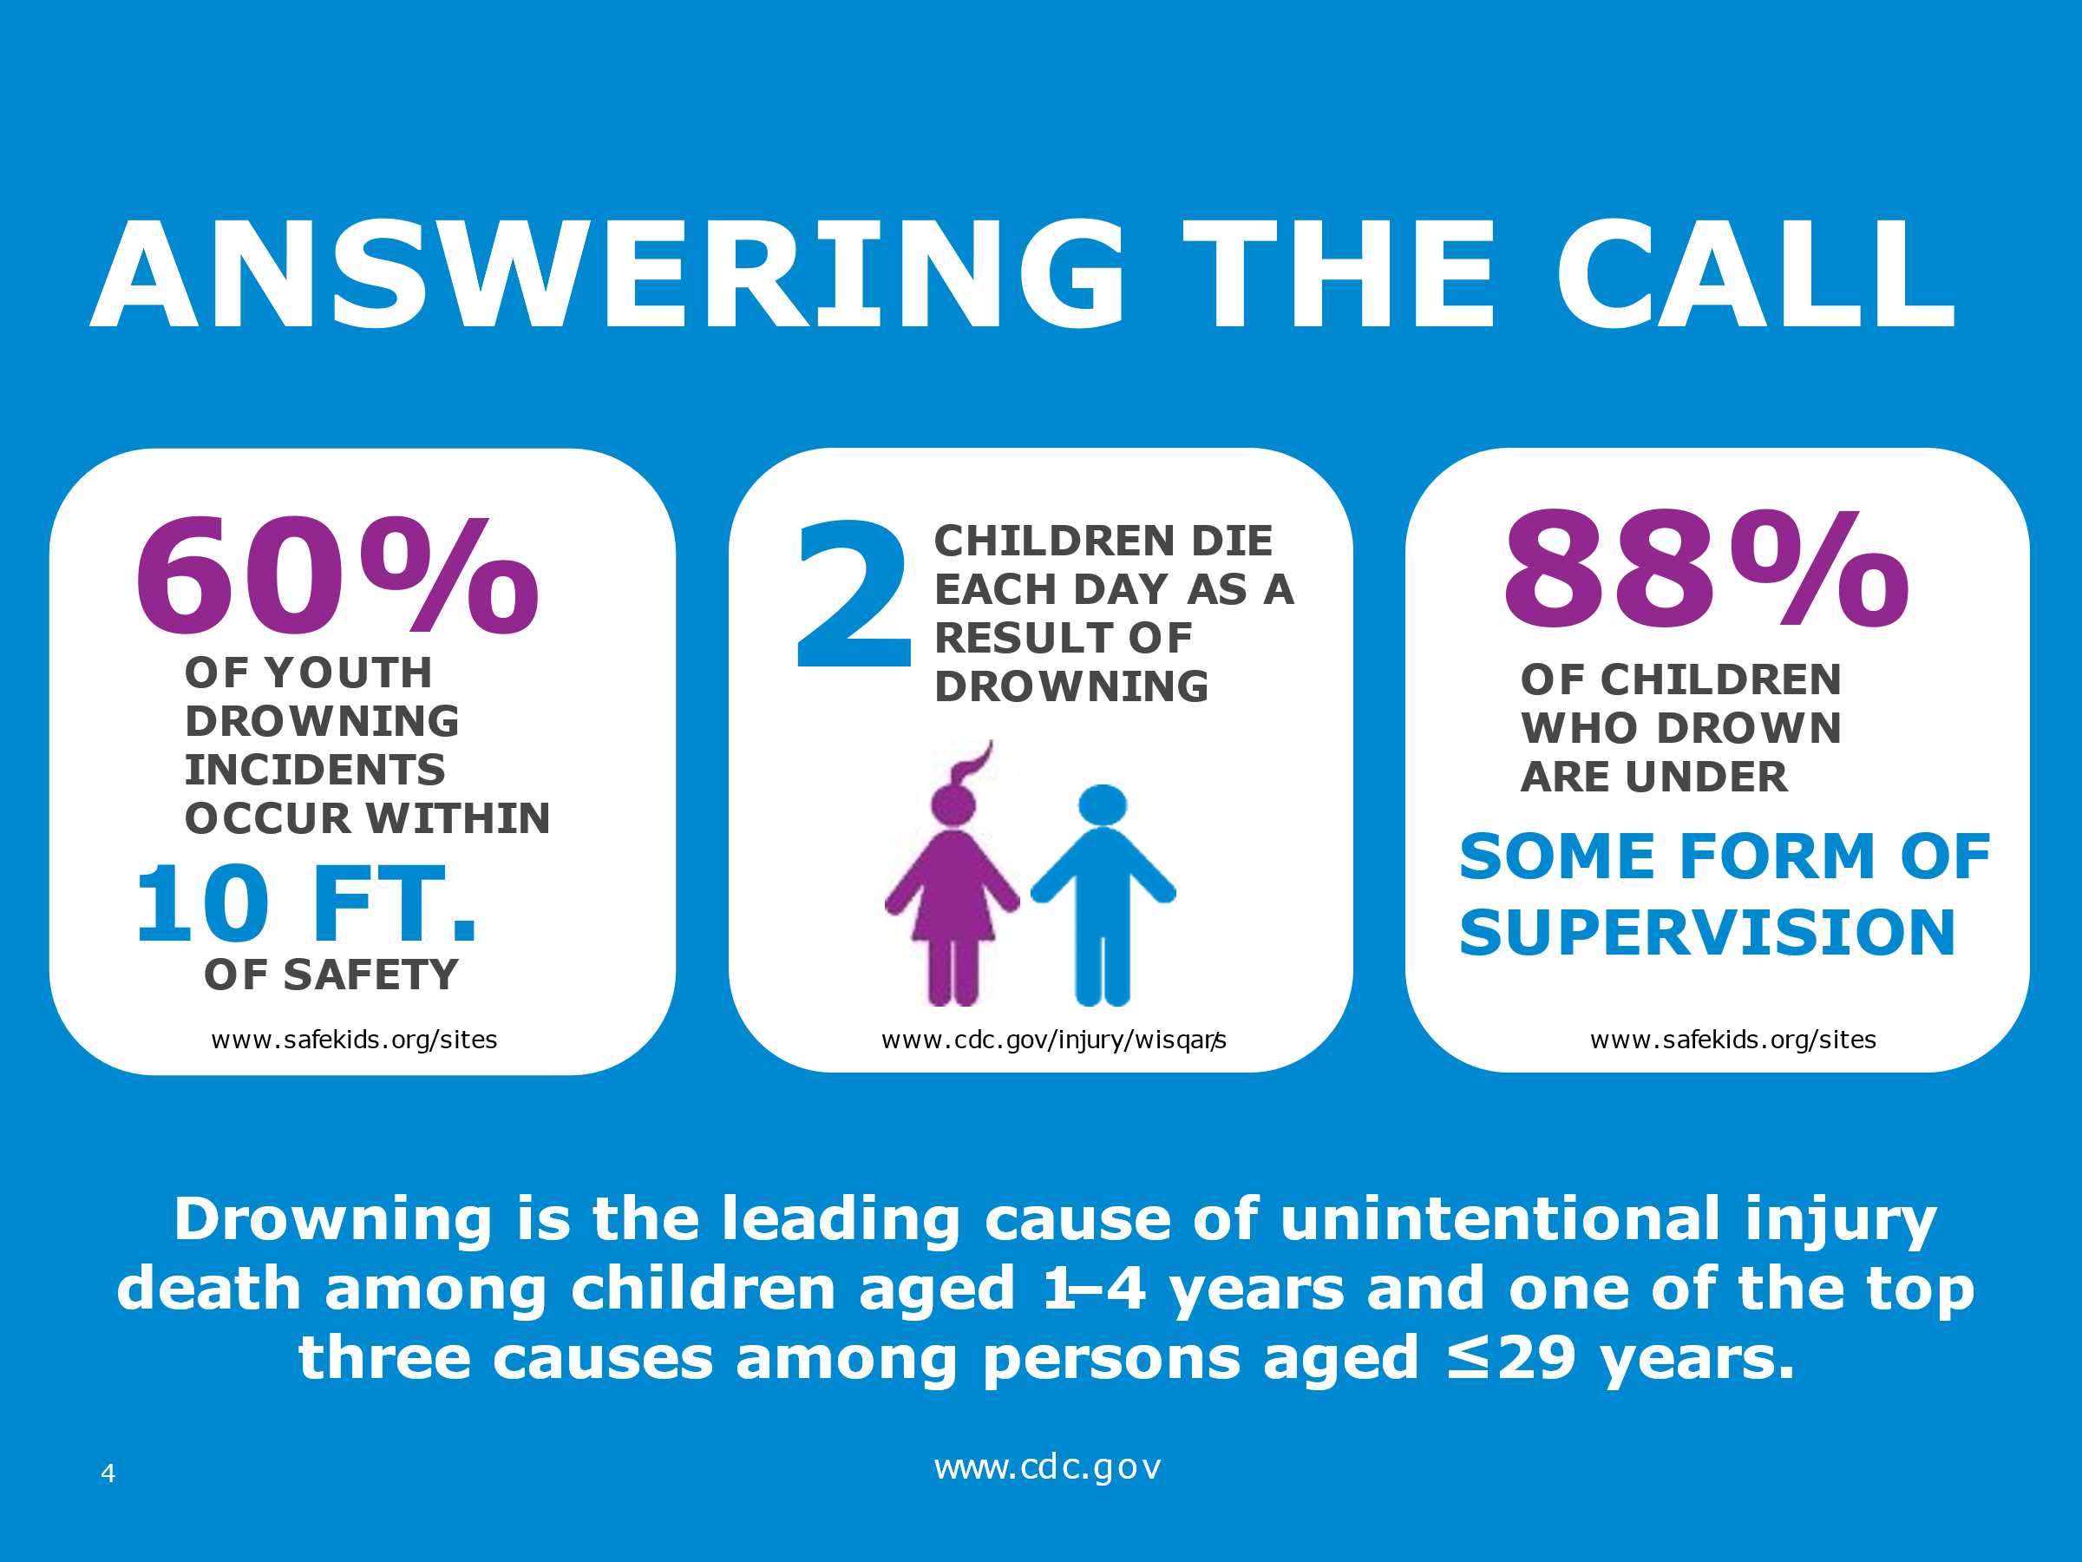

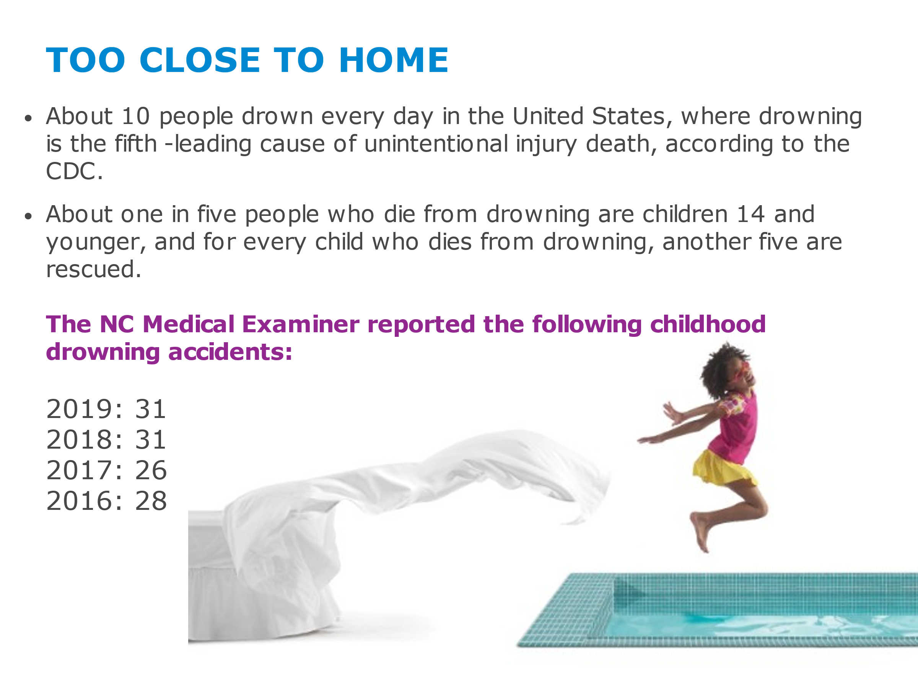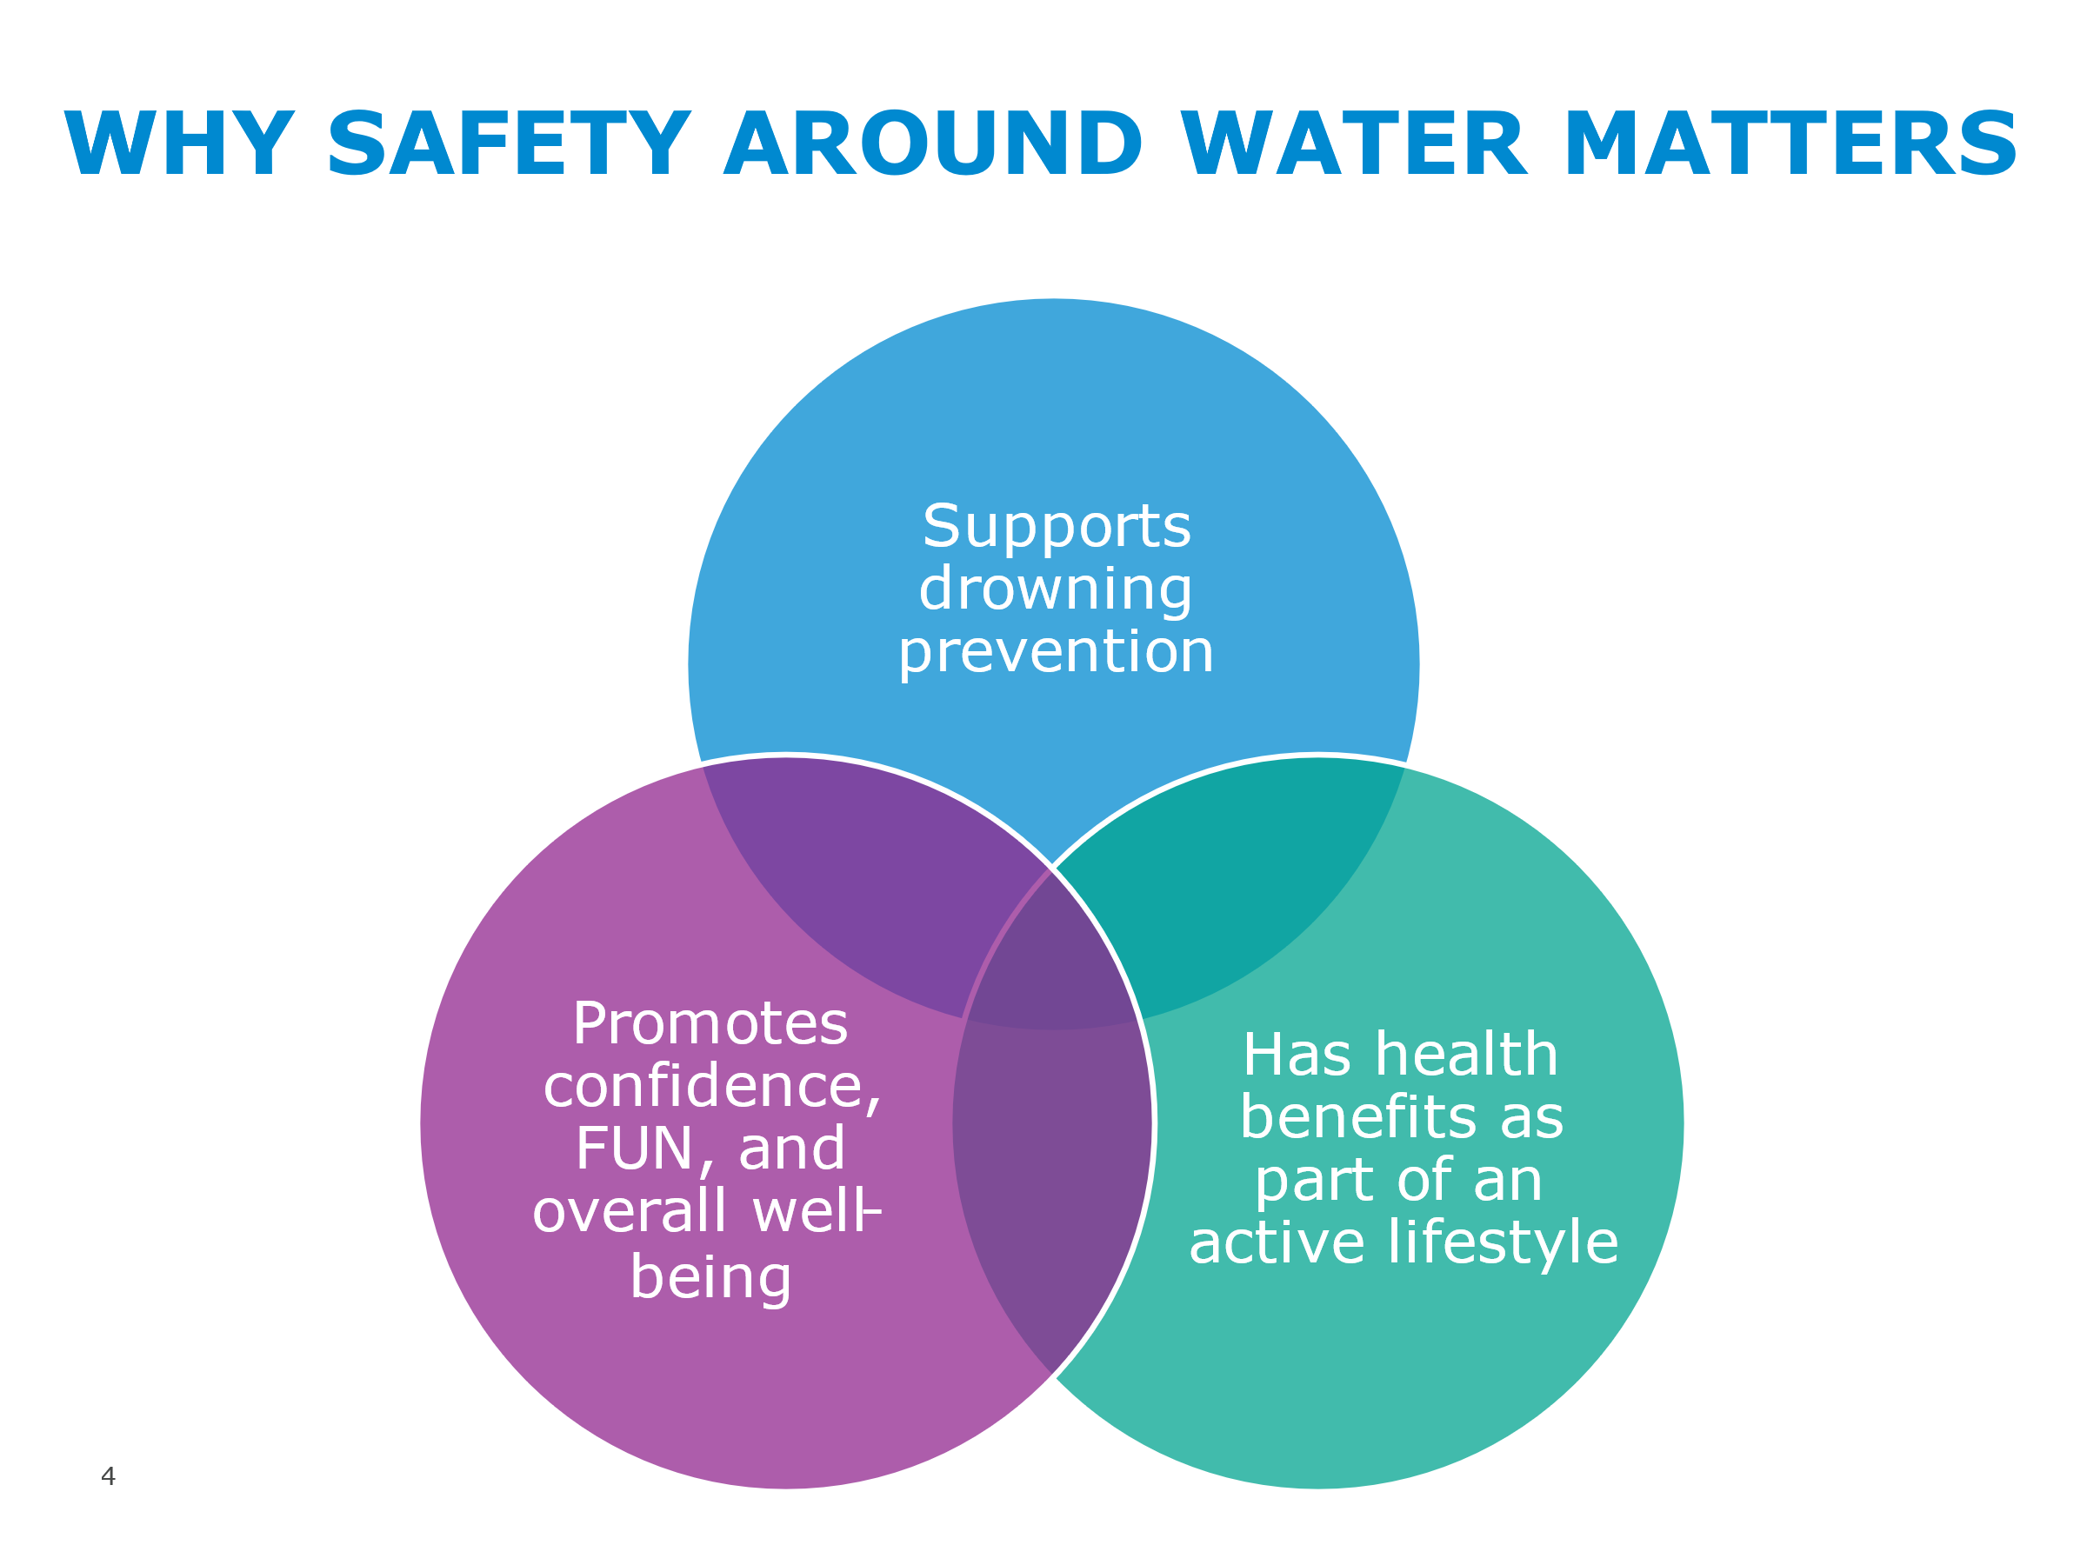

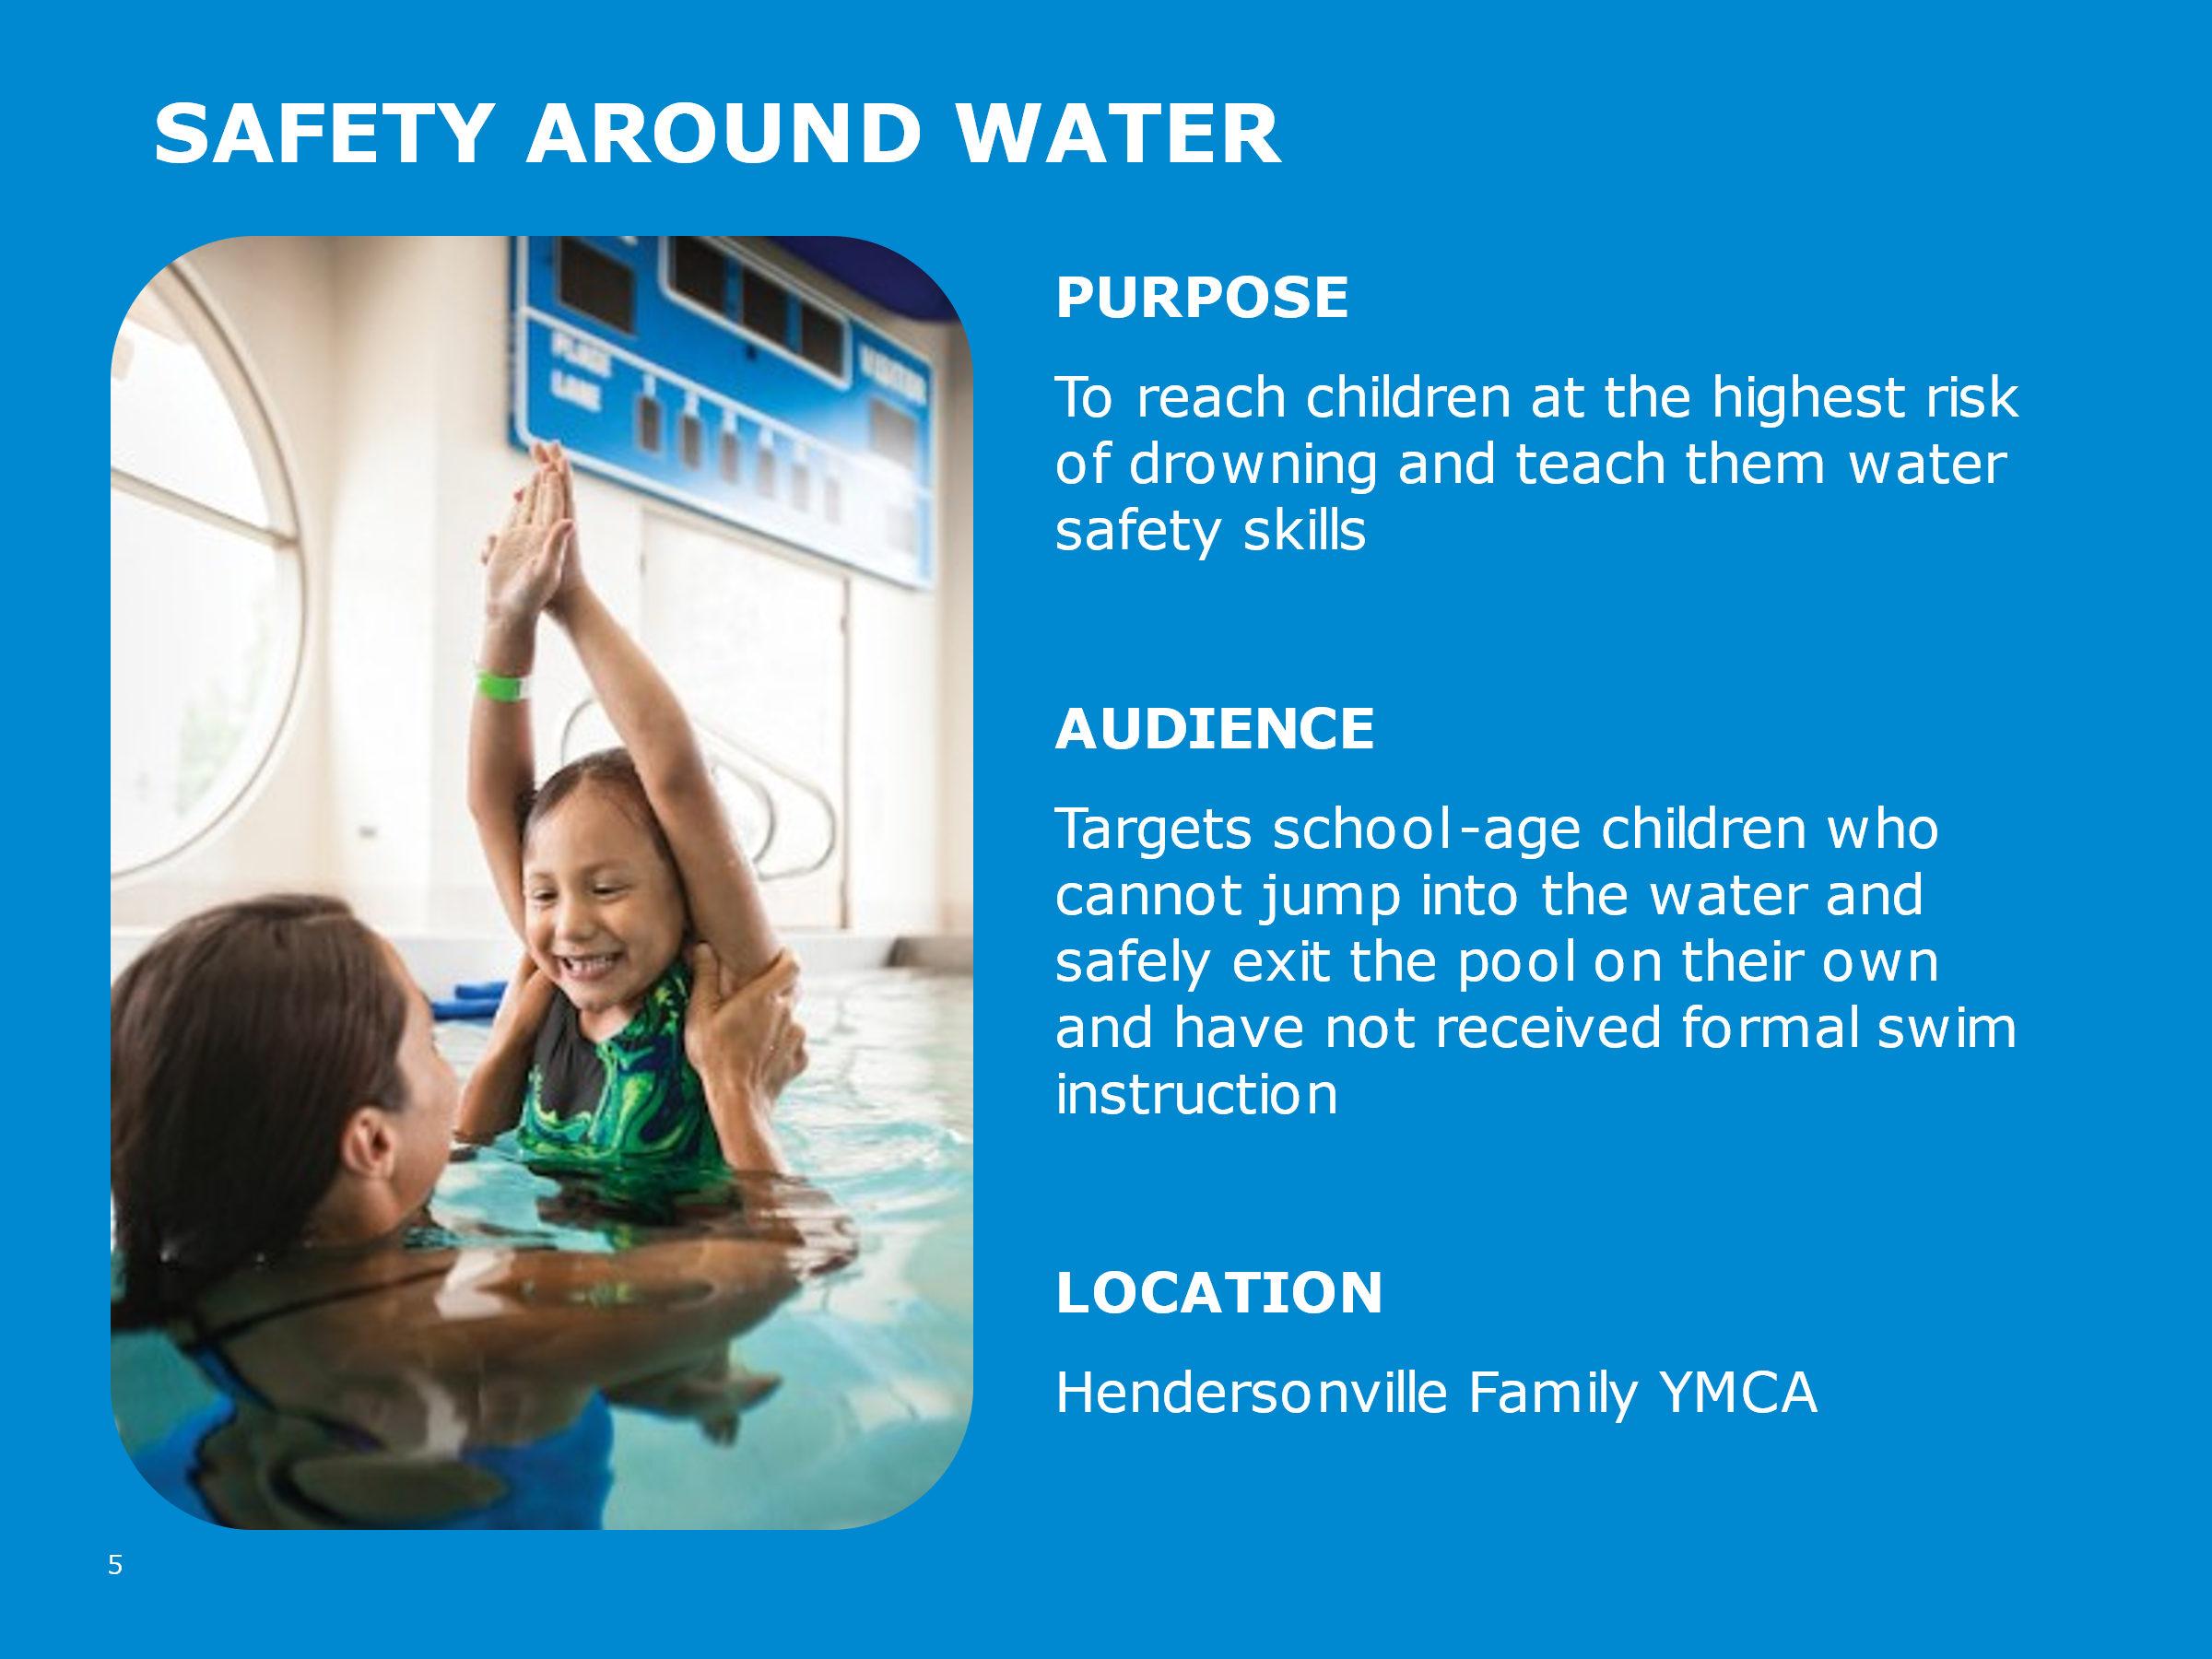
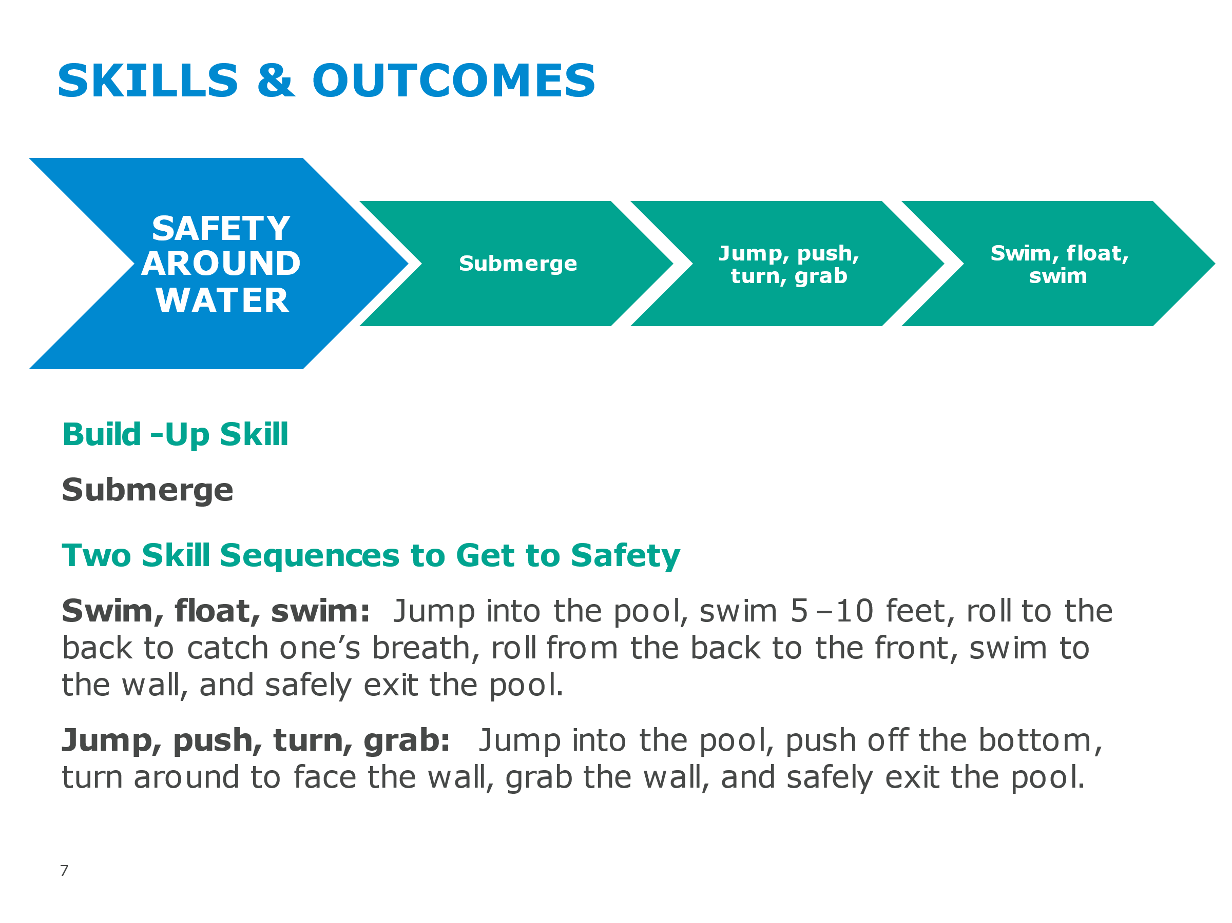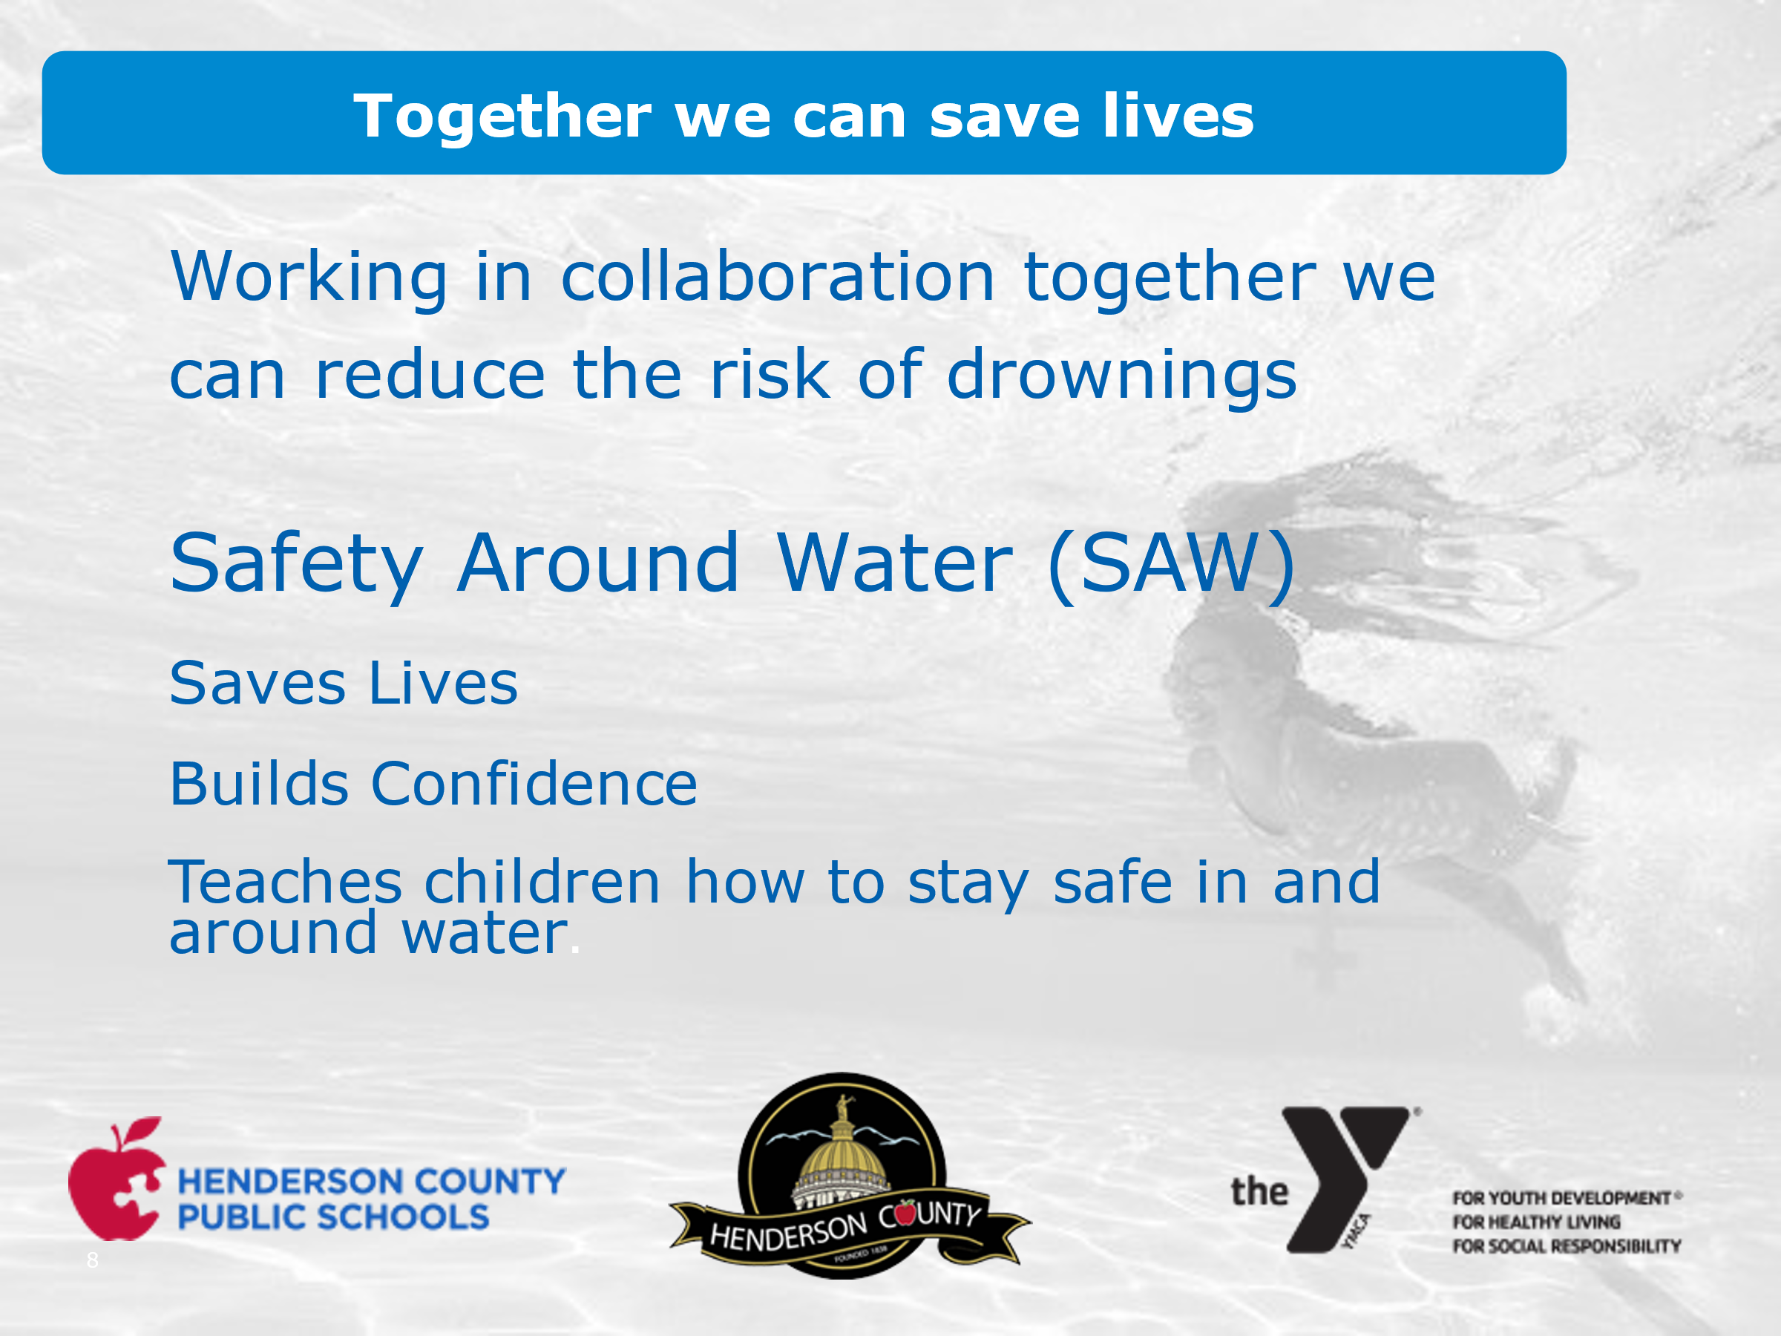
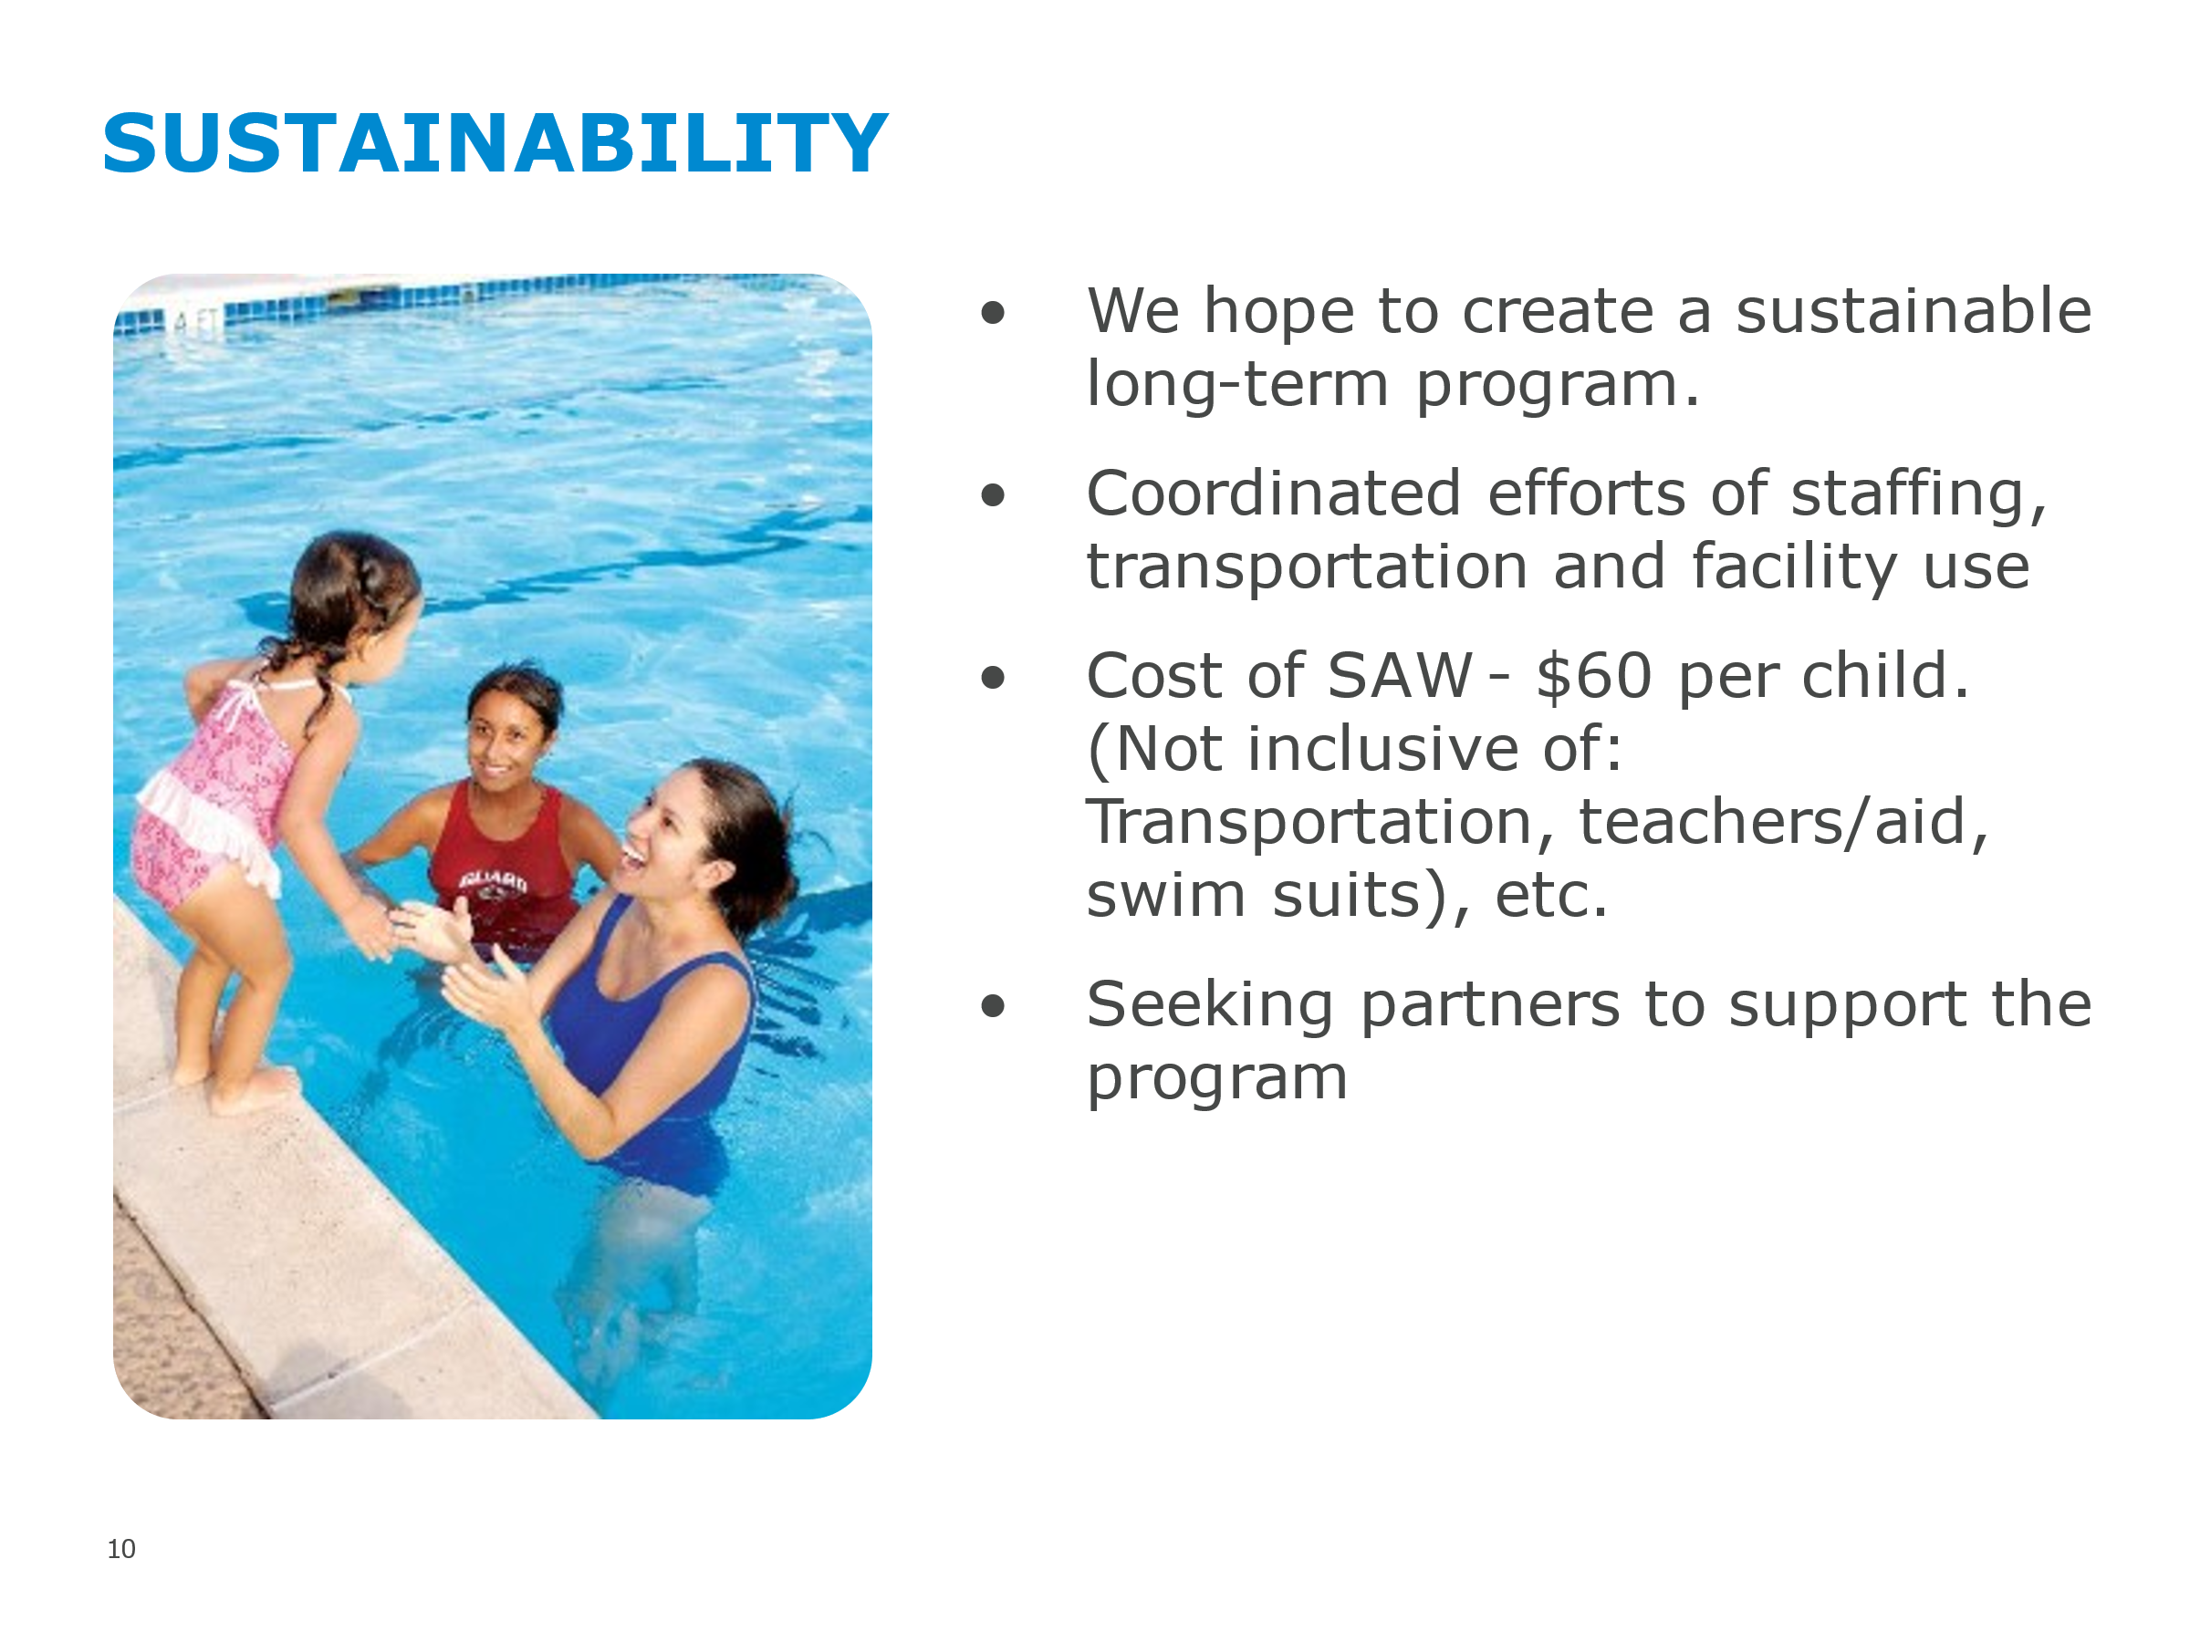

The Board asked that the charter schools and home schools be included.

Vice-Chair McCall note that there are approximately 1,000 Henderson County kids that would benefit from this program at $60 each totaling $60,000 per year.

Hendersonville Connections Center
Vice-Chair McCall had requested that Julie Huneycutt, provide the Board with information on the new Hendersonville Connections Center project.

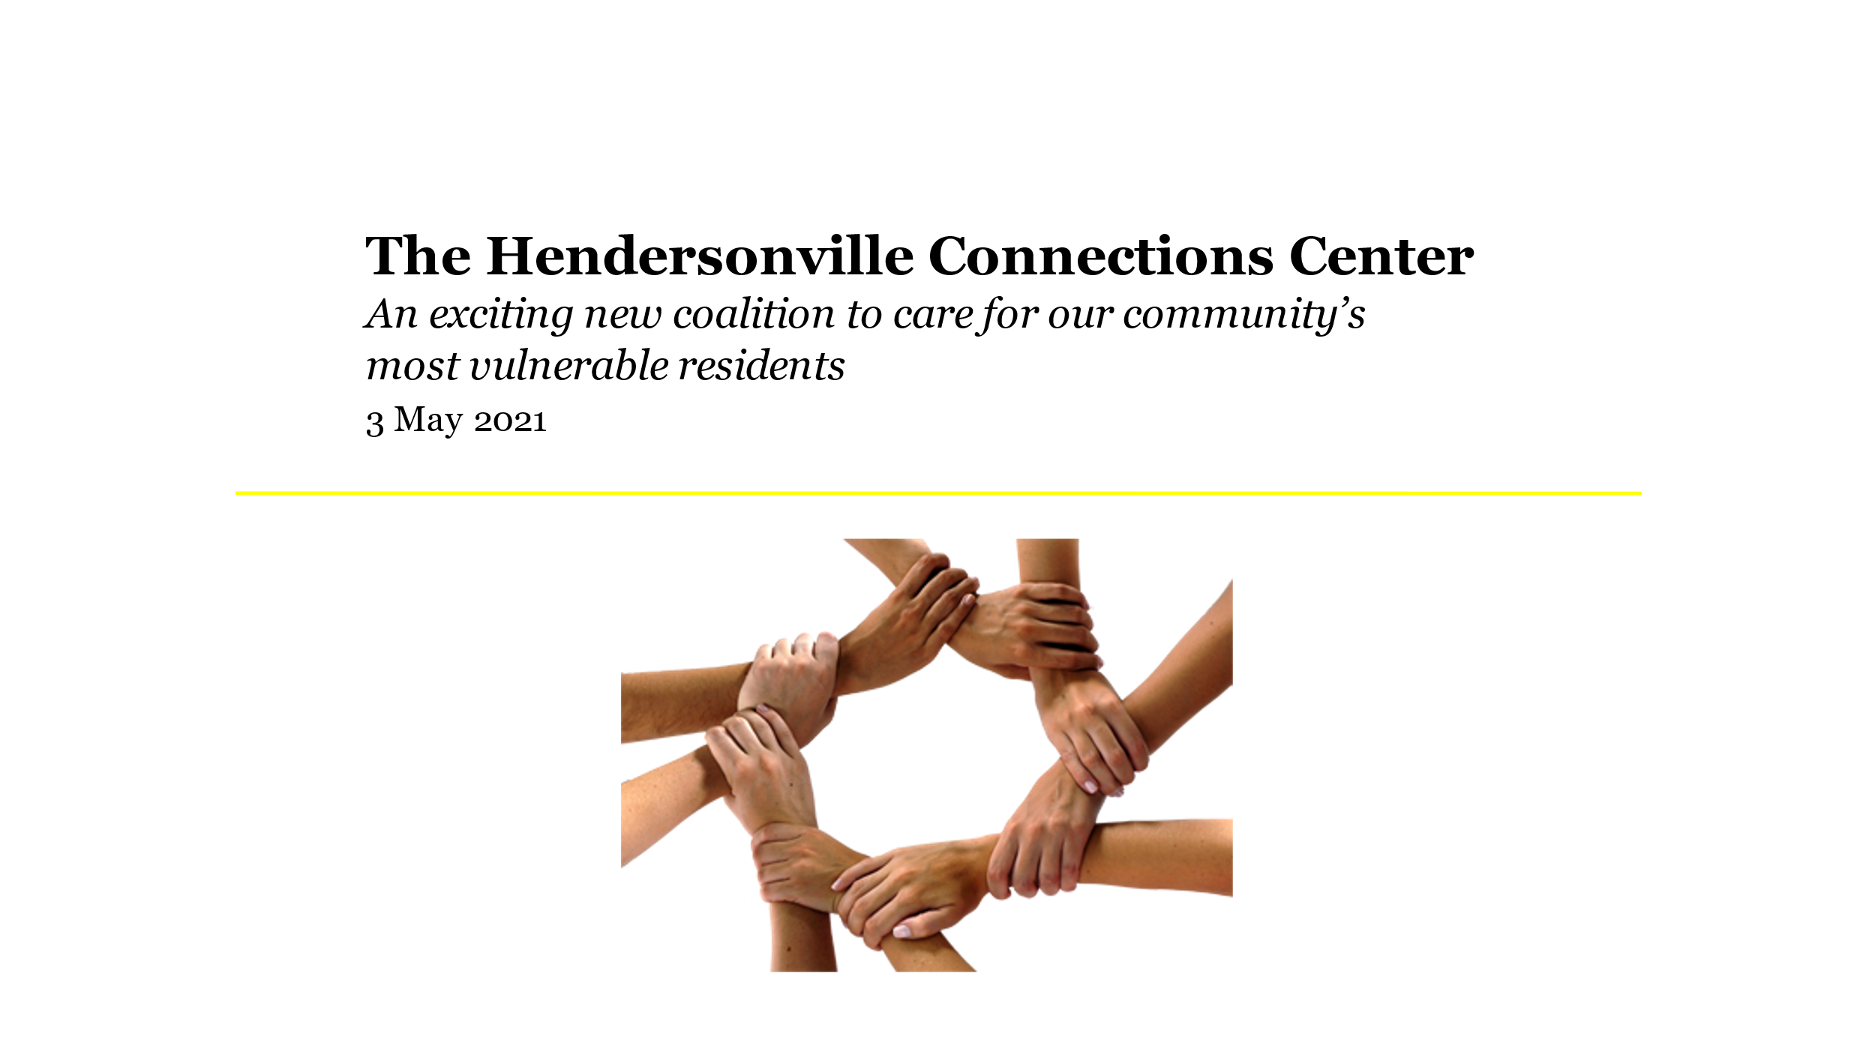

Judy Long provided the following presentation:

The Story Behind the Connections Center
https://vimeo.com/user138787054

Brief History
- March 2015: Joseph Outreach Ministry launched on 7th Avenue
- June 2017: Community conversations initiated about future of Joseph Outreach Ministry and care for vulnerable persons in Henderson County
- September 2017: Joseph Outreach Ministry suspended due to loss of lease
- July 2018: Community conversation linked with Grace Blue Ridge Congregation
- April 2019: Initial architectural drawings presented to HCC Board
- January 2020: Name officially changed from Joseph Outreach Ministry to Hendersonville Connections Center with NC Secretary of State
- February 2020: Memorandum of Understanding signed between Hendersonville Connections Center and Grace Blue Ridge
- February 2020: Cummings Foundation awards first capital grant for $100,000

Vision and Goals for the Hendersonville Connections Center
- A beautiful, welcoming, healing space with a meditation garden and intentional focus on person-centered whole-person care that honors the worth and dignity of every person;
- Access to necessary personal care for clients such as showers, laundry, storage, healthy snacks, and mail drop;
- Drop-in computer and WiFi access to enable on-line submissions of applications for housing, jobs, and other services;
- One-stop shop access to case managers/advocates of multiple social service organizations in one location;
- Recovery programming through the creation of a Peer Living Room (funded by US Department of Justice Comprehensive Opioid, Stimulant, and Substance Abuse Program); and a central location for classes, groups, and services.
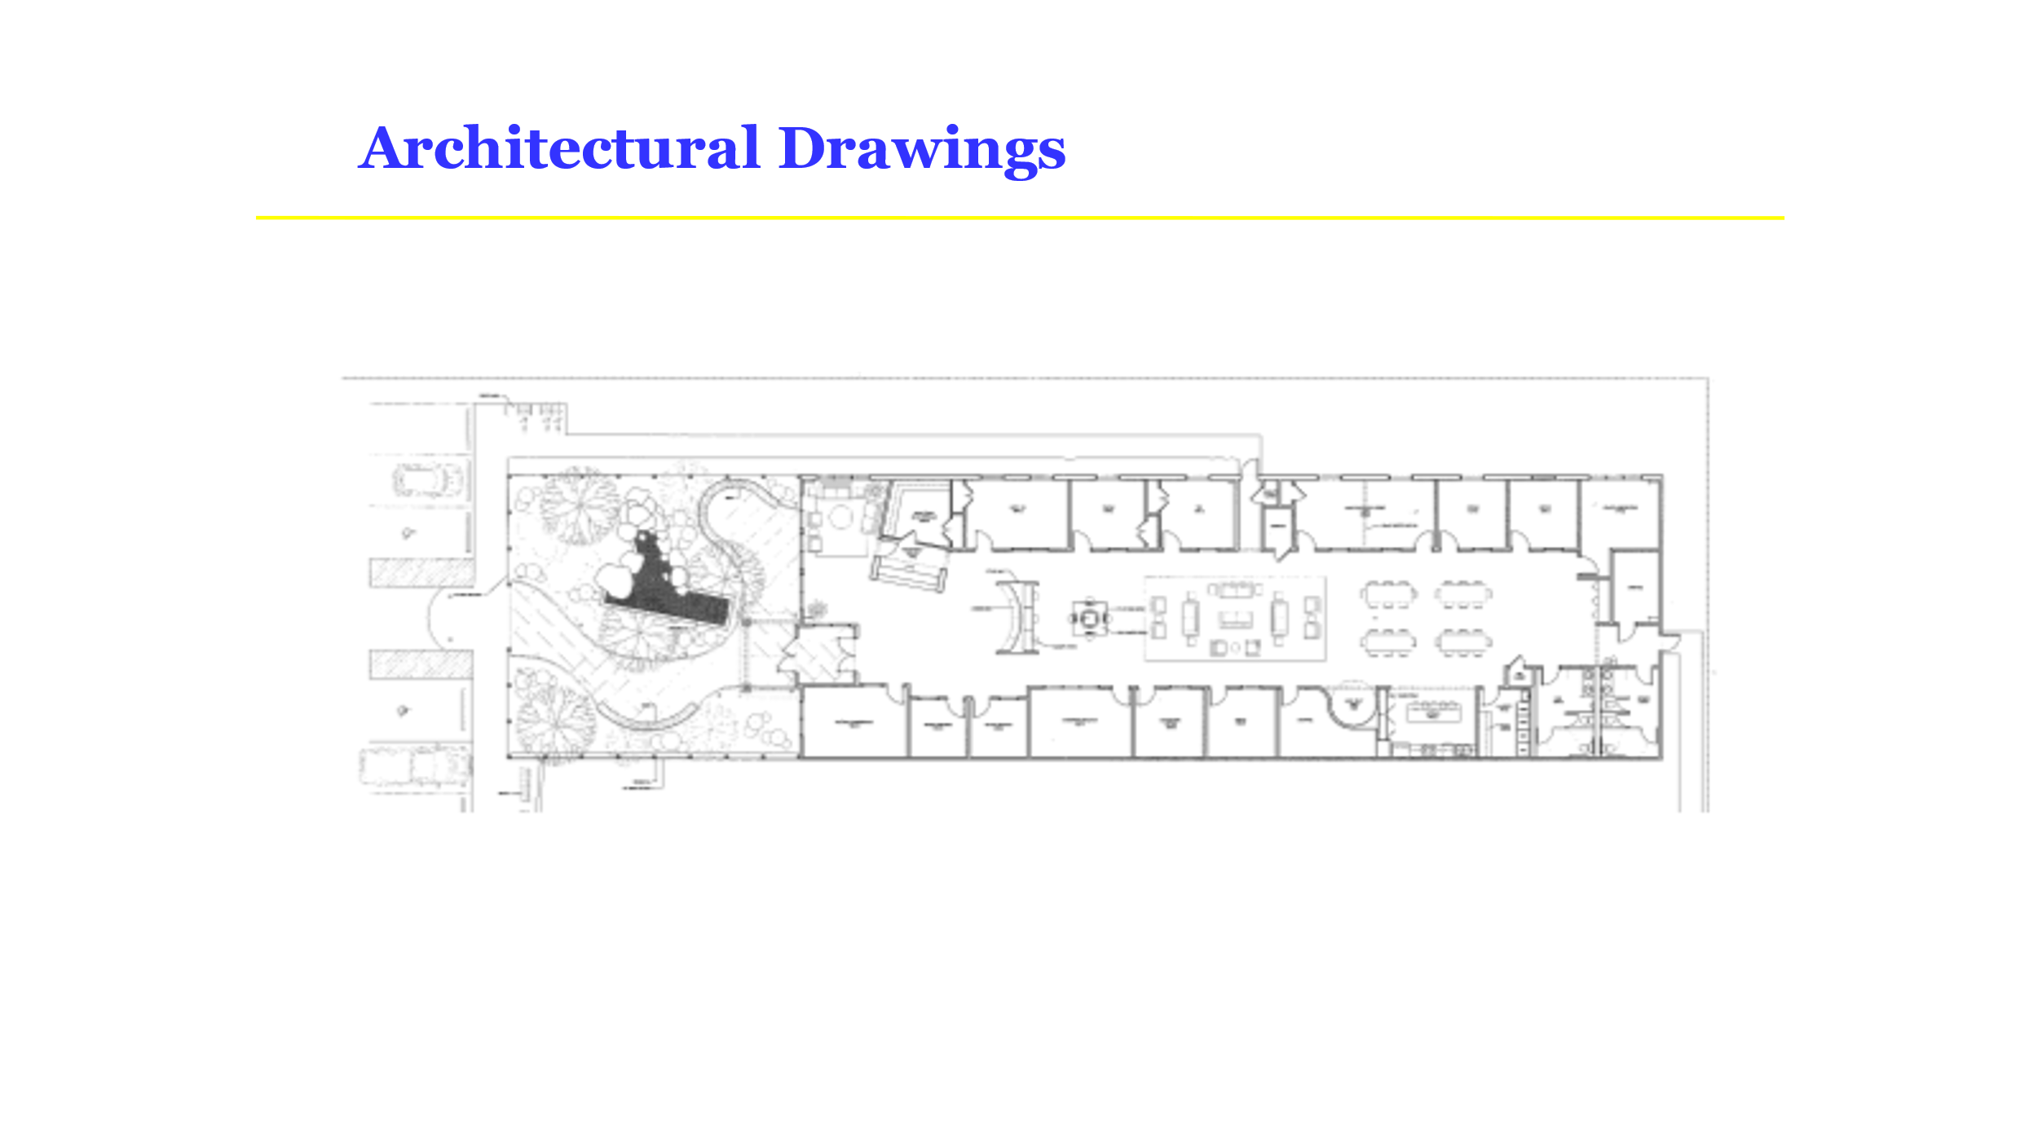

Hendersonville Connections Center Committed Partners
Committed Partners—representing issues of behavioral health, substance use disorder, housing, health, legal issues, and economic disenfranchisement
Blue Ridge Community College
Blue Ridge Health
Blue Ridge Humane Society
Crossnore School and Children’s Home
The Free Clinics
Henderson County Department of Public Health
Henderson County Department of Social Services
Henderson County Sheriff’s Office
Hope Coalition
Pisgah Legal
Safelight
Thrive
United Way of Henderson County

Renovation Project Budget & Funds Committed
Total Goal: $2,065,000
building renovations $1M
meditation garden $200k
furnishings and equipment $150k
campaign/project management $125k
COVID-related adjustment/increase to costs 40% $590k
Funds Pledged/Committed
Cummings Foundation $100k
Anonymous donor $35k
HCC Board giving $5k+
Funds Requested/Pending
Community Foundation of Henderson County
Dogwood Health Trust
Surrounding Municipalities
First Bank
Henderson County Request
Request from Henderson County Funds: $100,000
Request from American Recovery Act Funds: $1,500,000

Steve Wyatt informed the Board that $100,000 has been included in this year’s proposed budget subject to the Board’s approval and match by the municipalities.

General Assembly Updates
General Assembly updates include current and ongoing items of interest to the County related to the North Carolina General Assembly. Staff updated the Commissioners of any items that may affect the County as they arise while the General Assembly is in session.

Steve Wyatt stated HB704 (Sales Tax ¼% referendum) is being discussed in legislation. This Bill would allow Counties to use the Sales Tax toward school construction. He suggested the Board keep an eye on this Bill.

County Manager’s Report
The County Manager provided the Board of Commissioners with a brief update concerning any issues that should be brought to the attention of the Board. He noted May 19th the Board will discuss the budget for most of the day.

Last week two deputies in Catawba County lost their lives. Our Sheriff reached out to Catawba County with assistance, and our behavioral support staff were also utilized. He thanked the Board for the investment in our behavioral support staff.

Closed Session
The Board is requested to go into closed session pursuant to N.C. Gen. Stat. §143-318.11(a)(6), as allowed pursuant to NCGS 143-318.11 for the following reason:

(a)(6) To consider the qualifications, competence, performance, character, fitness, conditions of appointment, or conditions of initial employment of an individual public officer or employee or prospective public officer or employee; or to hear or investigate a complaint, charge, or grievance by or against an individual public officer or employee.

Commissioner Edney made the motion to go into closed session pursuant to N.C. Gen. Stat. §143-318.11(a)(1), (a)(6), as noted in the agenda package. All voted in favor and the motion carried.

ADJOURN
Commissioner Hill made the motion to go out of closed session and adjourn at 8:35 p.m. All voted in favor and the motion carried.

Attest:

Teresa L. Wilson, Clerk to the Board William Lapsley, Chairman

